“You must show the equations that is used in the calculation including the meaning of each symbol used in the equation. This explanation should appear side by side with the calculator so that when people do the calculation they can also refer to the equation.”

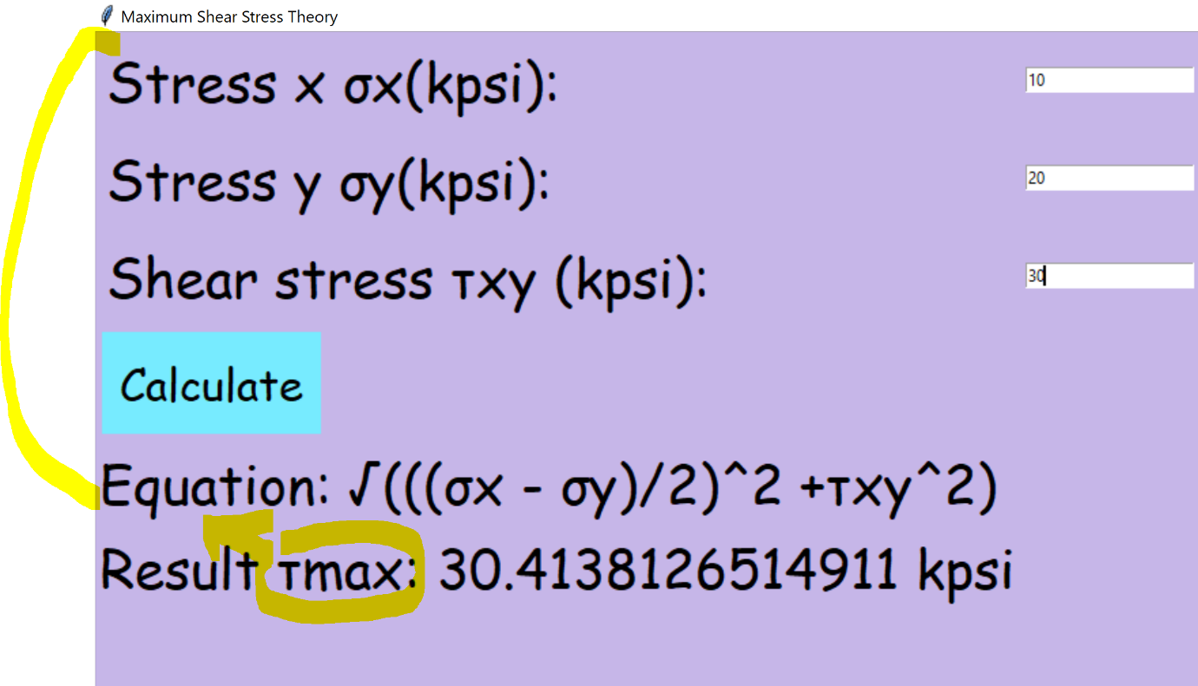

Add a navigation menu on top

Add a heading on top that should say:

**Maximum Shear Stress Theory (MSS)**

Then shift the part that says equation below the heading and replace the text equation with

Tmax : Equation for maximum shear stress in plane stress situation

Also mention the below formula for angle

And then this text should appear.

σx: Normal stress in X direction

σy: Normal stress in Y direction

τxy: Shear stress perpendicular to X axis and in Y direction.

Another result should also be shown which is the angle using the formula:

Equation for maximum shear stress angle in plane stress situation

**Add Units options also   
MPA or KPSI**

**Ductile Coulomb Mohr Theory:**

Same as above

Add heading on top

Then add formula as below:;

Failure Condition:



*σ*1 = *σA* and *σ*3 = *σB*

Distortion Energy Theory:

Same as previous.

Add heading on top and navigation menu.

Heading should say Distortion Energy Theory (Von Mises Theory)

Then add formula as below:

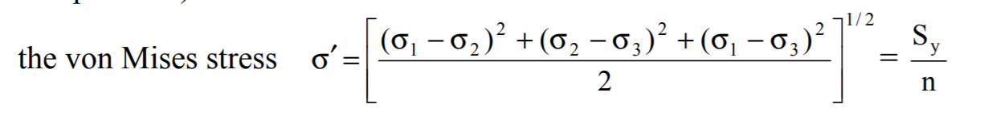

σmax = Max Principal Stress

Min principal stress (σmin)

Yield strength (Sy)

N= Safety Factor

Also add this equation for the user to calculate :

(σmax^2 - σmax*σmin + σmin^2)^0.5 < Sy/n

And same as ductile couloumb theory it should say success or fail

For Brittle: it is same as ductile coloum theory

Remove the tab for normal stress theory

For Brittle Coulomb Mohr theory

Follow as previous

Enter heading and a navigation menu

And then

Add show the formula

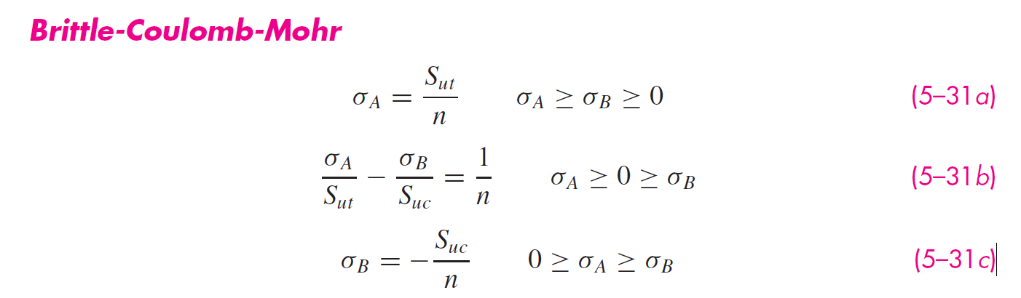

Modified Mohr Theory:

Same as brittle coulomb theory

Only difference: 